Project Title: Data Cleaning & Exploratory Data Analysis using Python (Pandas)
Prepared By: Sonu Sharma
Role: Data Analyst
Tools Used: Python, Pandas

Introduction
The purpose of this project is to clean and analyze a raw dataset using Python and Pandas.
The objective is to understand the structure of the data, remove inaccuracies such as duplicate and missing values, convert date formats, perform calculations, and export the cleaned dataset for further use.
Dataset Description
- The dataset contains information related to sales transactions.
- It includes features like Order Date, Country, State, Category, Sub-Category, Sales, Quantity, etc.
The dataset was loaded into Python for processing and analysis.
Methodology
Step 1: Importing Libraries
The Pandas library was imported to manipulate and analyze data.
Step 2: Loading the Dataset
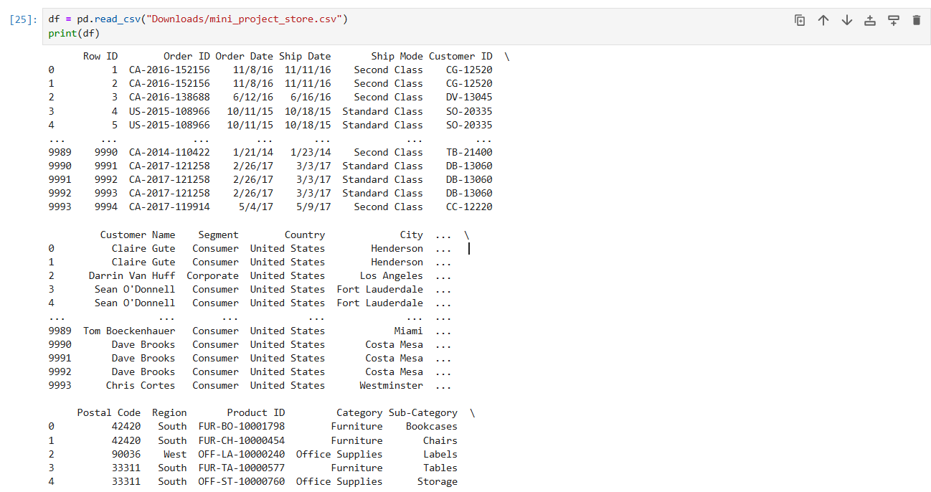

Step 3: Viewing Initial Records
To understand data structure:
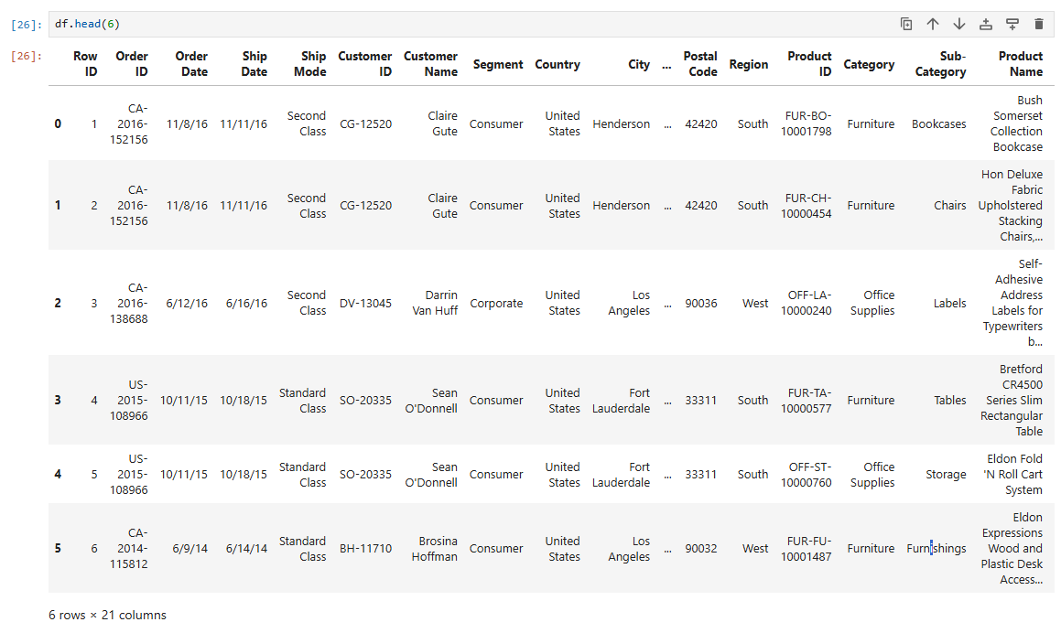
Step 4: Dataset Information
To check datatypes, columns & memory usage:
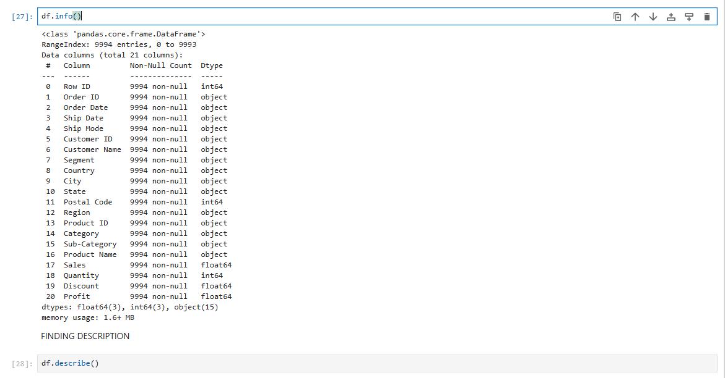
Step 5: Statistical Summary
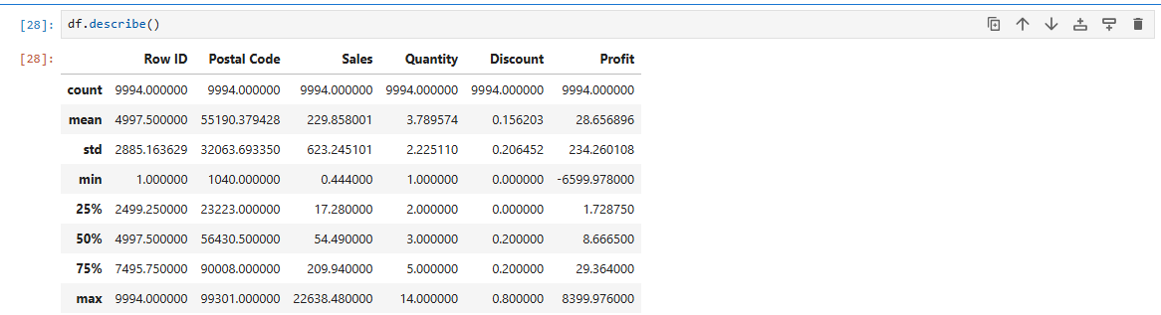
Step 6: Checking Shape (Rows & Columns)
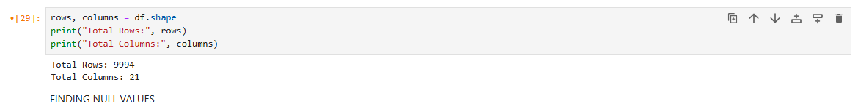
Step 7: Checking Missing Values
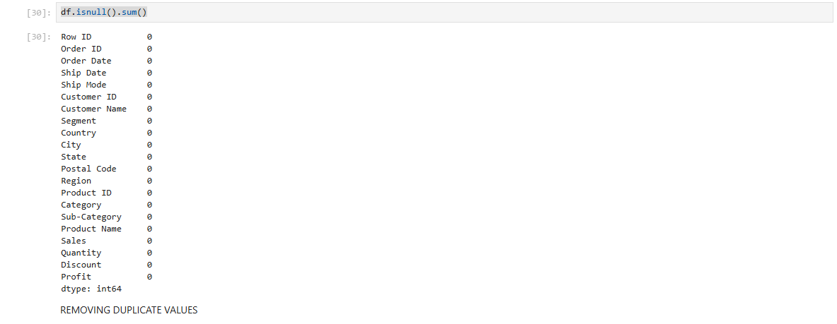Step 8: Identifying Duplicate Records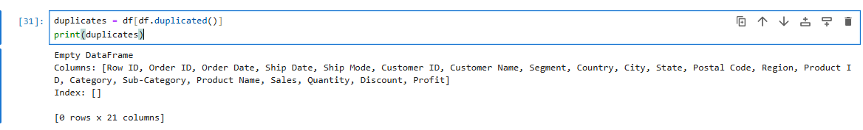
Step 9: Creating New Calculated Column
Calculating Selling Price
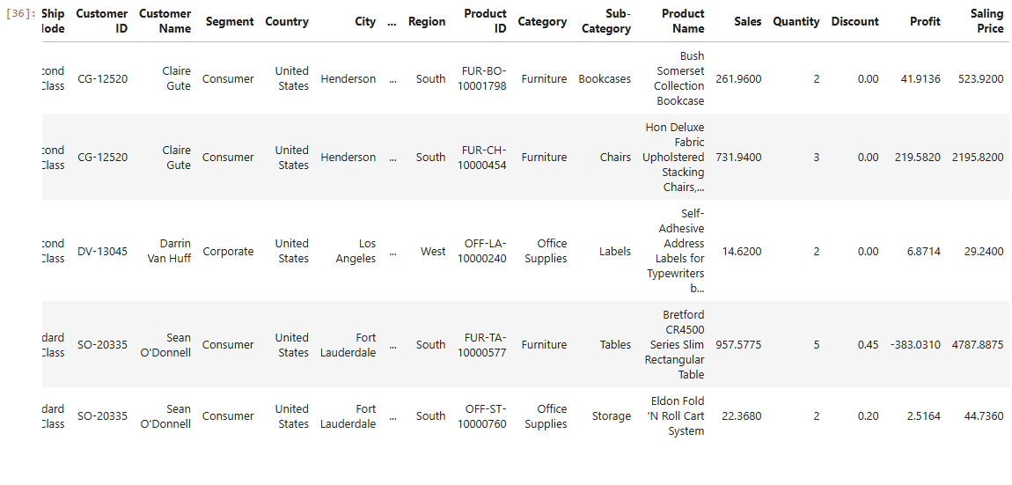
Calculating Purschase Price
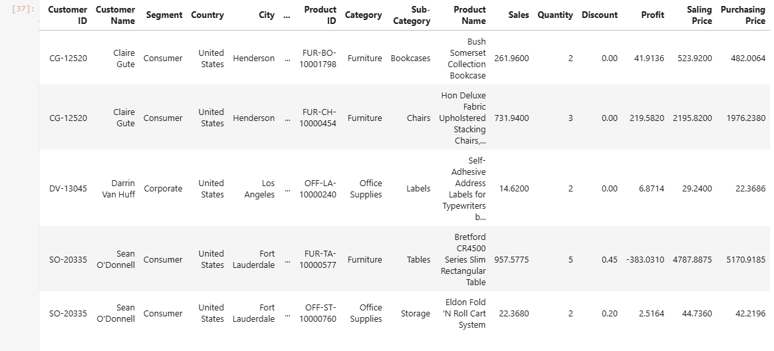

Step 10: Category-Wise Counts
Step 13: Exporting Cleaned Data
Results & Findings
- Dataset was successfully cleaned with no missing or duplicate values.
- Date column was converted to proper format.
- A new column Selling Price was calculated based on sales and quantity.
- Category-wise and state-wise distributions were identified.
- Cleaned file saved as mydata.csv.
Conclusion
This project demonstrates a complete data preprocessing workflow using Python Pandas.
The dataset is now fully cleaned and ready for dashboard creation, visualization, and advanced analysis.

